***How2 Add Python to C# Project***

1. Install the latest IronPython (Currently 3.4.1)  
   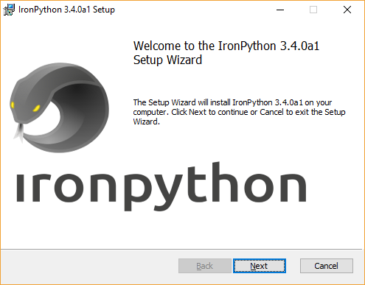
2. As part of the installation, this will include the “Iropython.dll” & “Microsoft.Scripting.dll” located at C:\Program Files\IronPython 3.4.
3. Open the VS C# Project.
4. Add ***Iropython.dll*** & ***Microsoft.Scripting.dll*** reference to the C# Project using “Browse” then pointing to the location during the “add reference” process.   
   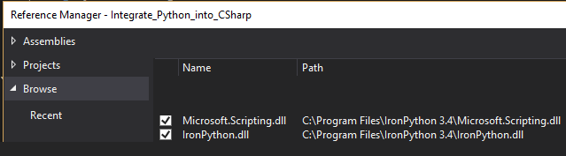  
   *Note, you may need to remove the original Microsoft.Scripting reference before adding this one to the project.
5. Install-Package DynamicLanguageRuntime using NuGet  
   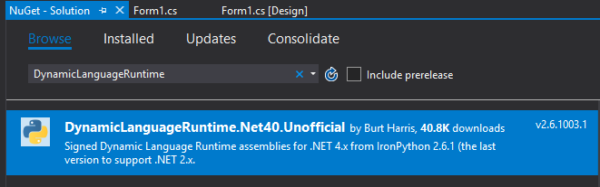
6. Add the following to the project references:  
   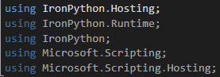
7. Here is a code example for integrating python code to c#

Example:

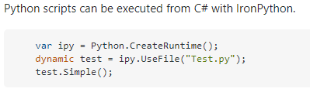

Reference:

<https://ironpython.net/>

<https://github.com/IronLanguages/ironpython3/releases/tag/v3.4.0-alpha1>

<http://putridparrot.com/blog/hosting-ironpython-in-a-c-application/>